***\\SESG6039 – Composites Engineering Design and Mechanics - Individual Assignment 1  
CLPT CALCULATOR***

***Name:*** *Abhinandan Thour* ***Student ID:*** *32453515*

***Question 1)***The code matches the results of the worked example as shown:

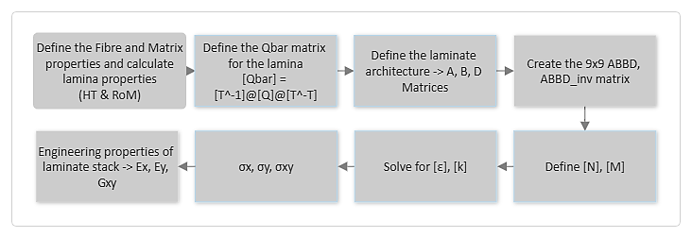

Figure 1 - Flow Chart of the CLPT Calculator

**STEP 1 - Define the Fibre and Matrix properties and calculate lamina properties (HT & RoM)**

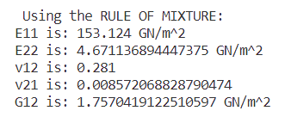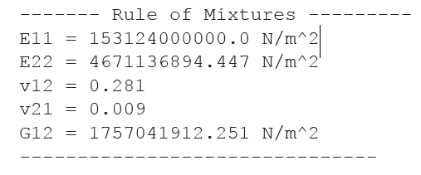***Rule of Mixture:***  
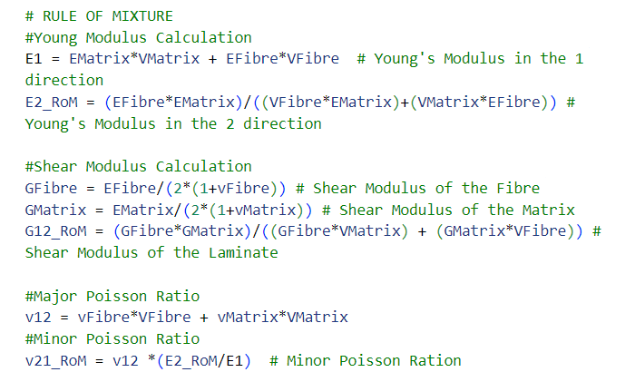

Figure 2 - Results calculated (RoM)

Figure 2 - Results in the Worked example (RoM)

Figure 3 - Code to calculate Properties (RoM)

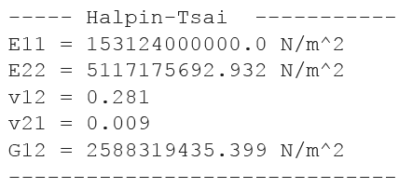**Halpin-Tsai:**

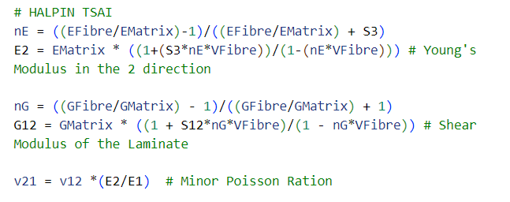

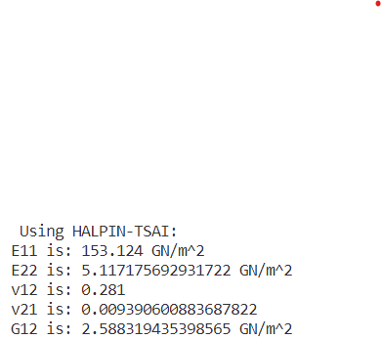***STEP 2 - Define the Qbar matrix for the lamina -> [Qbar] = [T^-1]@[Q]@[T^-T]***

Figure 5 - Code to calculate Properties (HT)

Figure 4 - Results calculated (HT)

Figure 3- Results on the Worked example (HT)

* ***Calculating Q matrix***

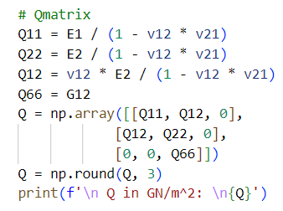 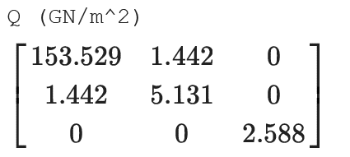

Figure 6 - Results of Q from worked Example.

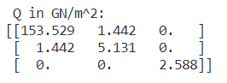

Figure 8 - Code to calculate the Q matrix.

Figure 7 - Results of Q calculated.

* 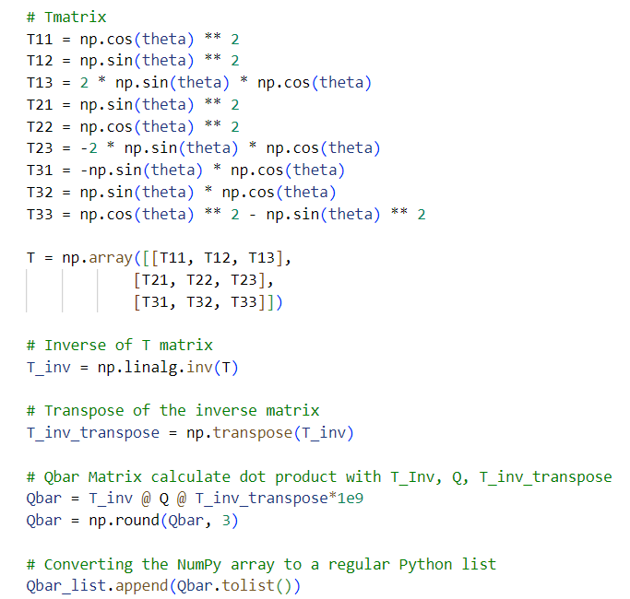***Calculating Qbar***

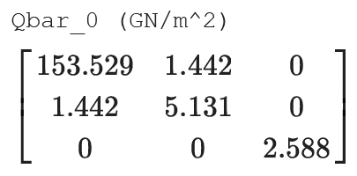

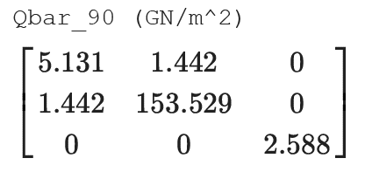

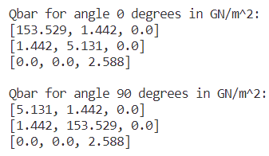 Figure 9 - QBar from worked example.

Figure 10 - QBar calculated.

Figure 11 - Code to calculate the Qbar matrix.

To calculate various Qbar matrices, a for loop was employed to iterate through different angle orientations. Subsequently, the results were stored in separate lists defined prior to the start of the loop. This procedure was repeated for the [A], [B], and [D] matrices as well.

**STEP 3 - Define the laminate architecture -> A, B, D Matrices**

* ***A Matrix Comparison***

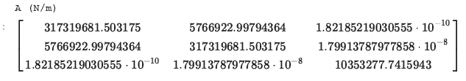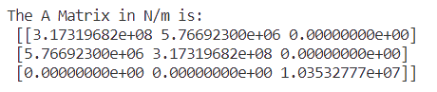

Figure 12 – A Matrix Comparison

* ***B Matrix Comparison***

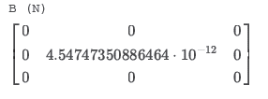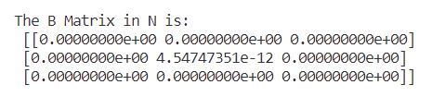

Figure 13 – B Matrix Comparison

* ***D Matrix Comparison***

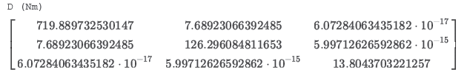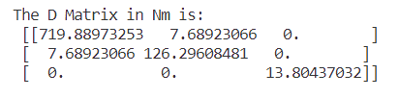

Figure 14 – D Matrix Comparison

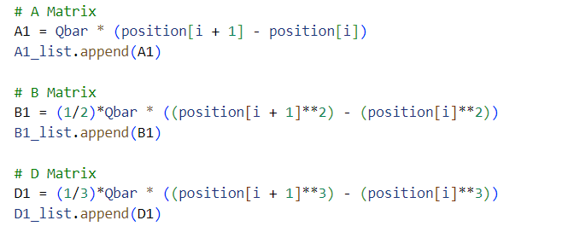 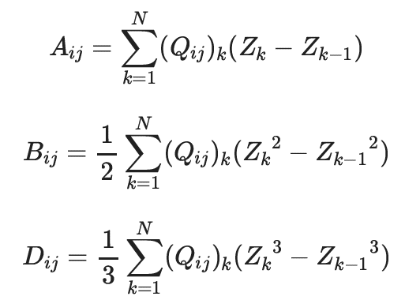

Figure 15 – Code used to generate [A], [B] and [D] Matrix Comparison

Figure 16 – Formula provided to calculate [A], [B] and [D] Matrix Comparison

**Step 4 - Create the 9x9 ABBD, ABBD_inv matrix**

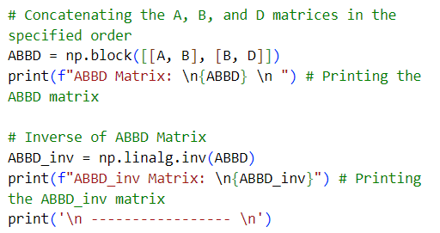 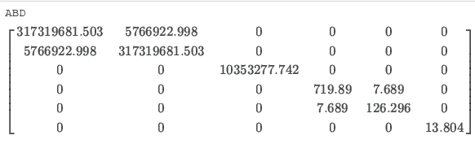

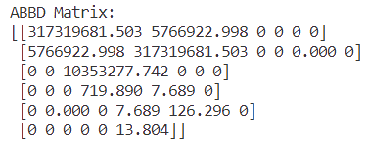

Figure 18 – Code to create ABBD and ABBD_inv Matrix

Figure 17 – Comparison of the ABBD matrix

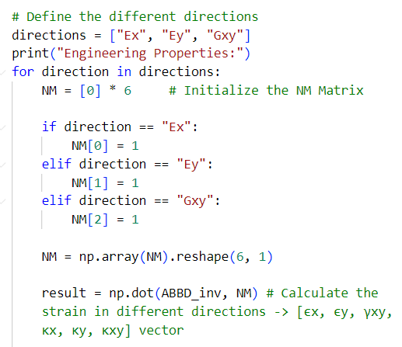**Step 5, 6 - Define [N], [M] and Solve for [ε], [k]**

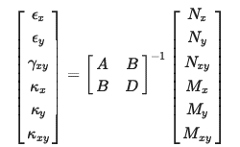

Figure 20 – Code to calculate strains in different directions

Figure 19 – Correlation between strain, ABBD and NM Matrices

**Step 7, 8 - σx, σy, σxy and Engineering properties of laminate stack -> Ex, Ey, Gxy**

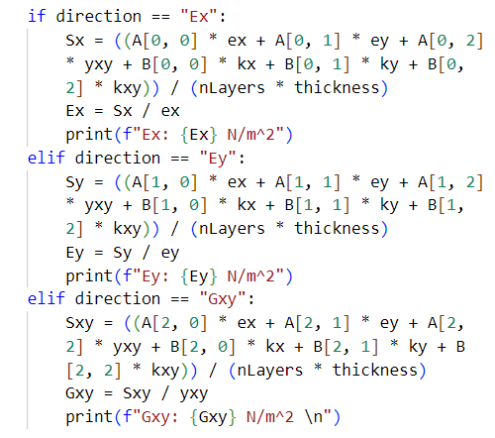



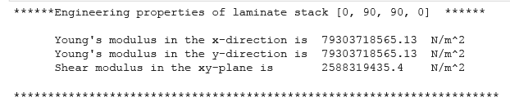

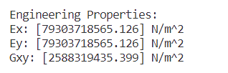

Figure 21 – Comparison of Engineering Properties

Figure 22 – Code to calculate Engineering Properties

***Question 2)***

|  |  |
| --- | --- |
| ***Laminate configuration*** | *[-45, +45, 0, 90, 90, 0, 0, 90, 90, 0, +45, -45]* |
| ***Thickness****:* | *0.2mm* |
| ***Young’s Modulus in 1 direction*** | *E1 = 54 GPa* |
| ***Young’s Modulus in 1 direction*** | *E2 = 18 GPa* |
| ***Poisson Ratio of the laminate*** | *v12* ***=*** *0.28* |
| ***Shear Modulus of the laminate*** | *G12* ***=*** *6 GPa* |

Table 1 - Configuration information for Q2, Q3, Q4

A Matrix:

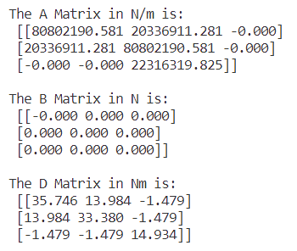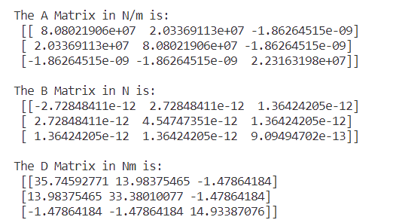

Figure 24 – Calculate A matrix –Long Form

Figure 23 – Calculate A matrix – Short Form

D Matrix:



Figure 26 – Calculate D matrix –Long Form

Figure 25 – Calculate D matrix – Short Form

***Question 3)***

B Matrix:



Figure 28 – Calculate B matrix –Long Form

Figure 27 – Calculate B matrix – Short Form

The B matrix represents the coupling stiffness matrix and accounts for the coupling between in-plane and out-of-plane deformations. In a symmetric laminate, the properties on both sides of its midplane are balanced, resulting in no coupling between these deformations. This symmetry simplifies the analysis.

However, the computed B matrix may not be exactly zero due to various reasons of which:

* *Computational Error:* In numerical calculations, the precision of the computer or software being used can introduce small errors. Although in theory the B-matrix should be zero for a perfectly symmetric laminate, these small numerical errors or rounding issues can lead to non-zero values, typically in the order of very small numerical values, which are practically negligible.
* *Approximations:* Engineering calculations often involve certain approximations and simplifications to enhance computational efficiency. While the B-matrix should ideally be zero for a perfectly symmetric laminate, these approximations may lead to small non-zero values in the calculations.

In practice, the deviation from a completely zero B matrix is typically attributed to these numerical and approximation factors and is considered acceptable as long as the values remain sufficiently small and do not significantly impact the overall analysis.

***Question 4)***

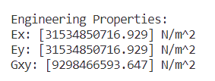

Figure 29 – Calculated Engineering Properties

Both Ex and Ey are equal at [31.534] GN/m². This indicates that the material exhibits isotropic behaviour in the x-y plane. The high values of Ex and Ey indicate that the material is relatively stiff and resistant to deformation in both the x and y directions. This stiffness makes it suitable for applications where rigidity is essential. The shear modulus Gxy, measuring the material's resistance to shear deformation in the xy-plane, is [9.298] GN/m². This suggests that this combination of high Young's moduli and a substantial shear modulus is designed to provide both structural strength and stability against shear stresses, making it suitable for applications where stiffness and shear resistance are critical.

***Question 5)***

|  |  |
| --- | --- |
| **Laminate configuration** | *[90, 45,-45, 0]* |
| **Thickness**: | *0.125mm* |

Table 2 - Configuration information for Q5

The resulting matrices are:

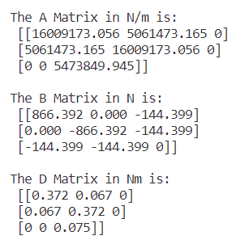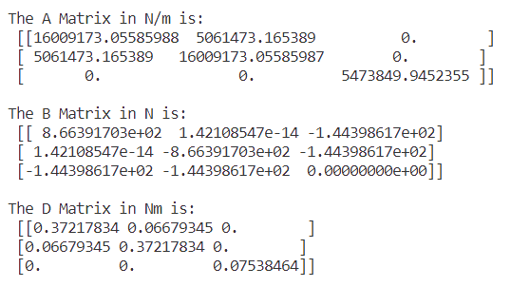

Figure 31 – Calculate A, B, D matrix –Long Form

Figure 30 – Calculate A, B, D matrix – Short Form

The Young’s Modulus on the X and Y direction are:  
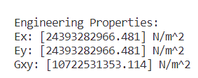

Figure 32 – Calculated Engineering Properties for Config 3

The change in stacking sequence in Question 5 compared to Question 2, while keeping the material properties constant, has led to differences in the laminate's performance. Despite being thinner (0.5mm) and having fewer layers, the laminate in Question 5 excels in Gxy (shear resistance), with a 115% improvement over the laminate in Question 2.

However, this improvement in Gxy comes at the expense of in-plane stiffness (Ex and Ey), which are only 77% of their corresponded values in Question 2. The results indicate that the stacking sequence in Question 5 prioritizes shear resistance over in-plane stiffness.

Additionally, the reduced thickness in Question 5 demonstrates that the laminate achieves similar Ex and Ey values with just 1/5th of the thickness of Question 2. This suggests that for applications where thickness is a concern, the laminate in Question 5 may be more efficient.

The similarity in the strain results for the x and y directions shows that the Ex and Ey values are the same. Analysing the strain matrices, it is evident that the resulting matrices are perpendicular to each other. This perpendicular is confirmed by the dot product with the [NM] matrix, which yields the same value for their corresponding rows.

Strain values for the x direction: $\left[\begin{aligned}ε_{x}=81.989783900 \\ ε_{y}=-26.61715021 \\ γ_{xy}=-5.75451535\end{aligned}\right]$ Strain values for the y: $\left[\begin{aligned}ε_{x}=-26.61715021 \\ ε_{y}=81.989783900 \\ γ_{xy}=5.75451535\end{aligned}\right]$

The asymmetry of the laminate in Question 5 results in a non-zero [B] matrix, highlighting the presence of coupling effects between in-plane and out-of-plane deformations.